Enterprise Network 2350

Lab 4.1.1b Secure Services

GYIMP

Jacob Calvert, Timothy Zellers, Regan Stubbs, James Baker, Faustino Gonzales

Criteria #1a: Secure network device configuration files - Routers / Firewalls: SSH, OSPF

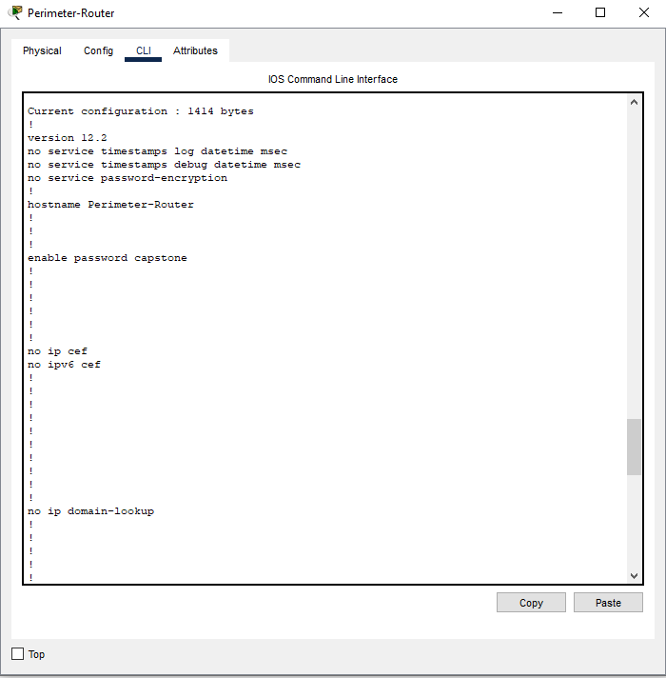

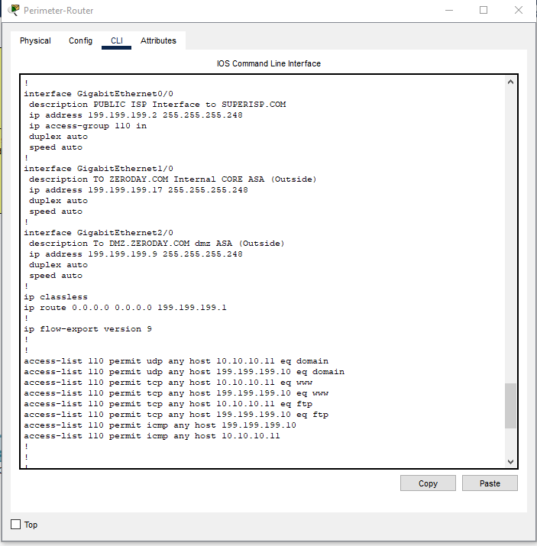

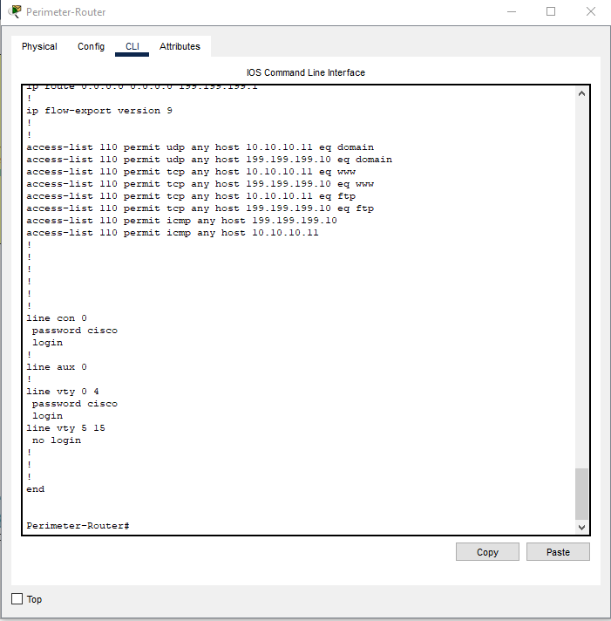

Criteria #1b: Secure network device Routers / Firewalls: Evidence controls operational – Packet Tracer

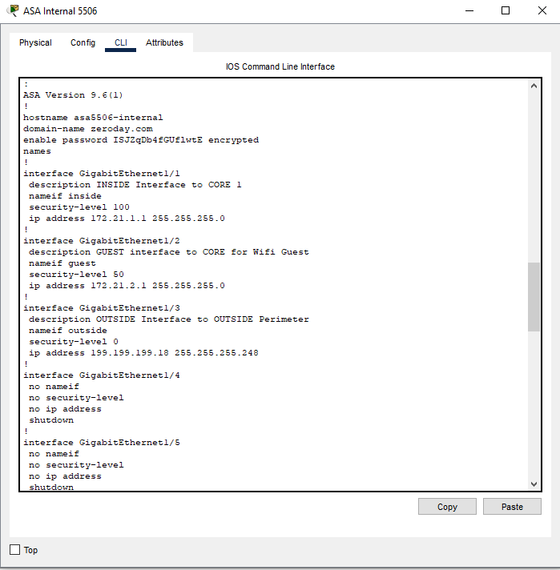

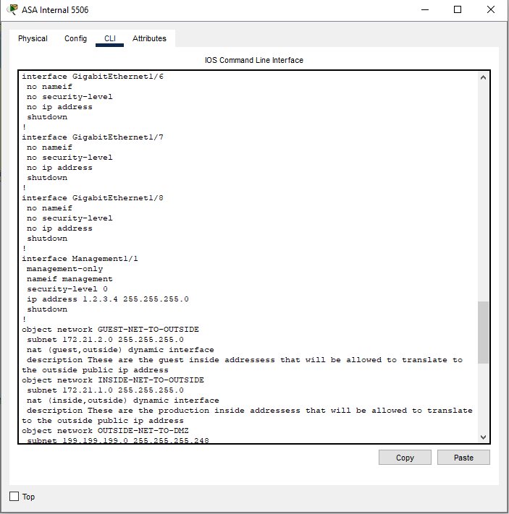

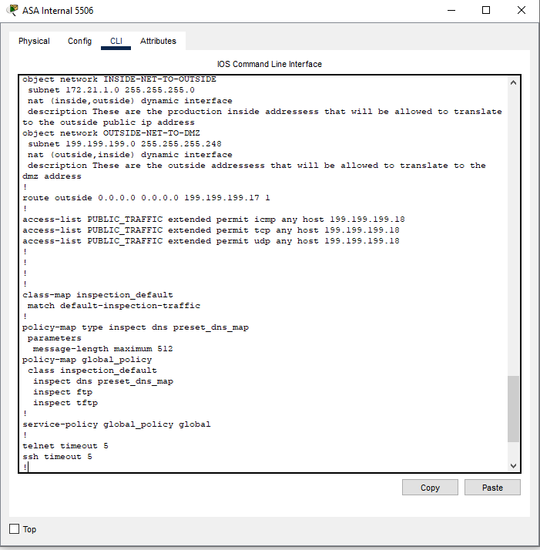

Criteria #2a: Secure Services Web Server External & Internal VMs configuration evidence

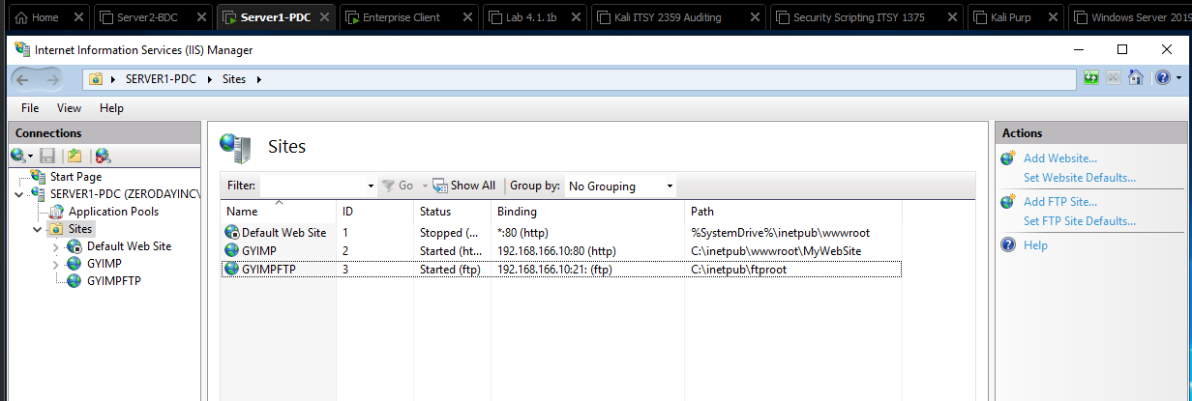

Criteria #2b: Secure Services: Client VM is able to securely access web servers using HTTPS & Certificates

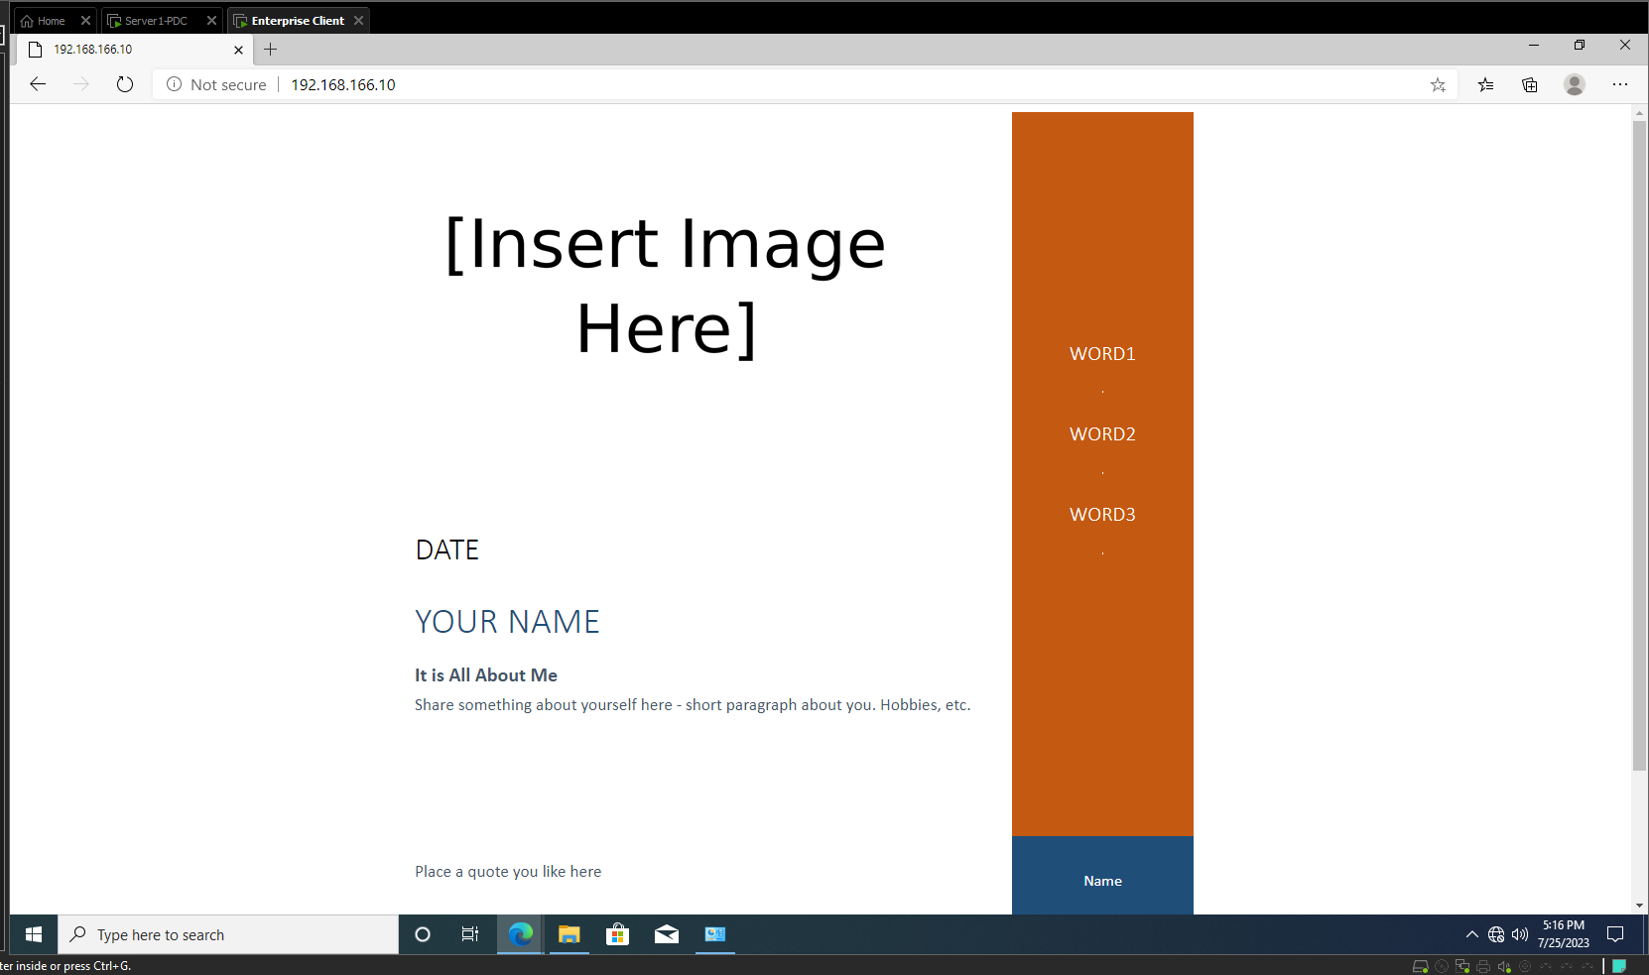

Criteria #3: Packet Sniffing Evidence valid network traffic / services

